DOMAIN NAME SYSTEM (NAT)

DNS : The Domain Name System (DNS) is the hierarchical and distributed naming system that translates human-friendly domain names (like www.google.com) into machine-readable numerical IP addresses (like 172.217.168.142).

How DNS works:

The Domain Name System (DNS) is essentially the internet’s phonebook. It translates human-friendly domain names (like www.whoapi.com) into IP addresses that computers use to identify each other on the network. Here’s a step-by-step breakdown of how DNS works:

* You enter a web address into your browser, such as www.whoapi.com.
* Your computer queries a DNS resolver. The resolver is usually provided by your internet service provider (ISP). It acts as the first point of contact in the DNS query.
* The resolver queries a root DNS server. The internet has a number of root DNS servers distributed globally. These servers don’t know the IP address for www.whoapi.com, but they can direct the query to a server that knows more about the .com part of the address.
* The query moves to a TLD (Top-Level Domain) DNS server. For www.whoapi.com, the TLD server is responsible for .com domains. The TLD server doesn’t know the exact IP address either, but it knows which Name Server is authoritative for example.com domains.
* The authoritative DNS server is queried next. This server knows the IP addresses for the whoapi.com domain (it’s 184.154.70.198) and can respond to the query with the IP address of www.example.com.
* Your computer receives the IP address 184.154.70.198 for www.whoapi.com from the DNS resolver and can now establish a connection to the website.

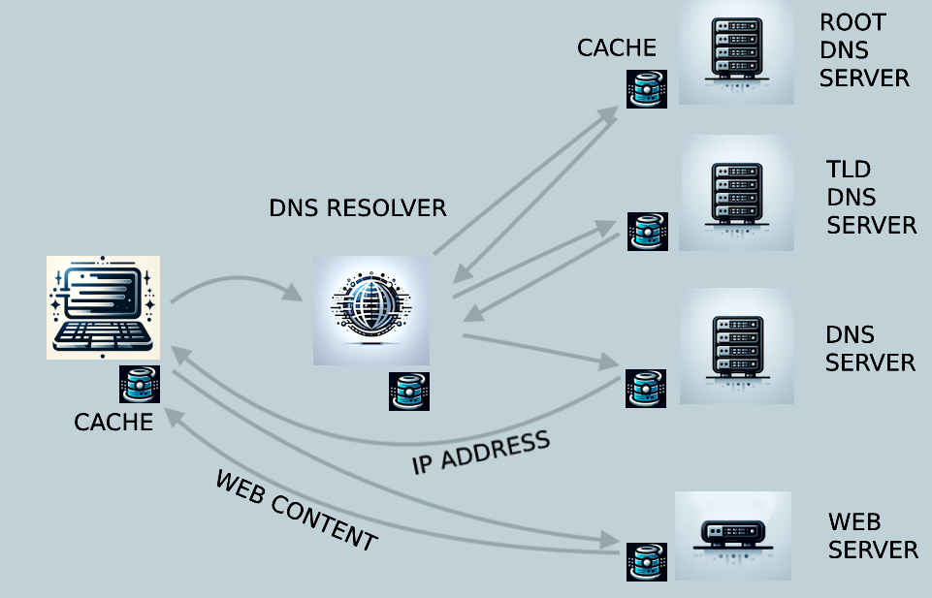

Common types of DNS records :

DNS records, stored on authoritative servers, contain information about a domain.

* A record : Links a domain name to an IPv4 address.
* AAAA record : Links a domain name to an IPv6 address.
* CNAME record : Creates an alias from one domain to another.
* MX record : Defines mail servers for a domain.
* TXT record : Stores text information, often used for email security.
* NS record : Specifies a domain's authoritative nameservers.
* SOA record : Holds administrative details about a domain.

DNS Hierarchy :

